**Project Design Phase-II**

**Technology Stack (Architecture & Stack)**

|  |  |
| --- | --- |
| Date | 15 October 2022 |
| Team ID | PNT2022TMID24576 |
| Project Name | AI-powered Nutrition Analyzer for Fitness Enthusiasts |
| Maximum Marks | 4 Marks |

**Technical Architecture:**

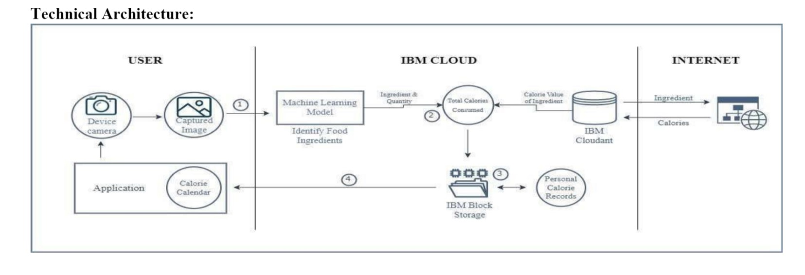

**Table-1 : Components & Technologies:**

|  |  |  |  |
| --- | --- | --- | --- |
| **S.No** | **Component** | **Description** | **Technology** |
|  | User Interface | An app that lets users make profiles, upload  photos of the components they use in their food,and obtain a personalized nutrition calendar. | HTML, CSS, JavaScript / Flutter |
|  | Registration | User registers with the application and verification of user details is carried out. | HTML , CSS ,JavaScript, Python |
|  | Image Capture | Users are required to take a photo of the ingredient(s) for which they want to know the detail about | IBM Maximo Image Inspection,  Device Camera |
| 4. | Machine Learning Model | The Image is classified, and the label is returned | Machine Learning & Deep Learning, Object Recognition Model to Label Ingredients |
| 5. | Ingredient Detection Model | The ingredient used must be identified from the image class. | Machin Learning And Image processing using python |
| 6. | Calorie Consumption Monitoring | The software monitors the user’s daily calorie intake and alerts them when there is an excess intake. | IBM Push Notifications |
| 7. | Database of Ingredients | Data Type, Configurations etc. Ingredient Information and the relevant calories are kept on database. | MySQL, NoSQL, etc. |
| 8. | Cloud Database for Back-up | Database Service on Cloud. Backup copies of the application’s data and consolidated reports are also stored. | IBM DB2, IBM Clouding etc. |
| 9. | File Storage | A File system is used to keep track of the products consumed each day as well as the daily caloric intake. Additionally, a customized calorie calendar. | IMB Block Storage |
| 10. | Calorie Value Consolidation | To determine the calorie counts of components that are saved in the database, a web-scraping API is used. | Beautiful Soup |
| 11. | Infrastructure (Server / Cloud) | The program is deployed to the cloud for use.  Configuration of the cloud. | Local, Cloud Foundry, etc. |

**Table-2: Application Characteristics:**

| **S.No** | **Characteristics** | **Description** | **Technology** |
| --- | --- | --- | --- |
|  | Open-Source Frameworks | Google Colab , VS code , online Websites | Python, HTML, CSS, Java Script |
|  | Security Implementations | Email-based data access authentication and text encryption before file storage | SMTP, Encryption Algorithms |
|  | Scalable Architecture | Application are updated, bugs are fixed, and new features are added in response to user experience and input. | Customer feedback, reviews, and Ratings. |
|  | Availability | Users should always be able to access the cloud – hosted application, and they shouldn’t any problems like application crashes. | IBM Cloud |
|  | Performance | The application should be able to process many requests without sacrificing the speed or quality of the results. | Testing – Black, White and Beta  Revise application in spiral model |